**Club** [**News:-**](News:-)

**Welcome**

Welcome to all our new P1’s and their families to Noosc and welcome back to our first proper Newsletter. P1’s have all settled in really well and the Bettridge Centre is full of laughter and noisy children (in their bubbles) once again.

Noosc has now been open for six weeks and we have been increasing our numbers each week as parent/carers return to work or the children pester their parents to come back. We are still following guidance from the Scottish government and the Care Inspectorate with regards to group size. We can have 30 in each group as in Schools. P1-3 in the lounge with the P4-7 in the large hall.

The children and staff will continue to be outside as much as possible and we are continuing with increased cleaning and hand washing/sanitizing. We have purchased a fogging machine from a grant we received from KPD this will enable us to ensure equipment, bus, playrooms are as clean and safe as possible.

Care Inspectorate have introduced legislation that we need to complete to keep them informed on how you think we are doing. You will be issued with a questionnaire please complete and return as soon as possible. This is especially important as we need to use your answers to plan for the future of the club during this difficult time. The children will also complete one but as part of our activities with staff.

Massive thank you to members who have donated money to keep the club financially viable. We continue to use our reserves to pay rent, wages etc but due to less income we may have to charge for spaces that are not being used. We will continue to monitor the situation and keep in touch with any changes.

Thank you for following our rule just now of no adults in the play centre. The children seem to enjoy coming in and leaving by themselves it is giving them more independence. We will continue to photograph white board and put it on face book so you know what they have had for snack and activities on offer.

**Dates for your diary**

Club Open

12th October to 16th October 7.30-6

Club closed 19th October to 23rd October

.

**Contact Us:**

Landline: 01569 731710 Mobile: 07793 561 748

Email: [noosc.office@gmail.com](mailto:noosc.office@gmail.com) Facebook: Noos Club

And as always - face to face. ☺

Please remember you need to give us at least 24hrs notice to cancel or you will be charged for the times you have booked, we employ staff for the numbers of children booked in and as a charity we need ensure we are covering our costs.

**Dates for your Diary**

**Club open**

**Our Gav at his best**

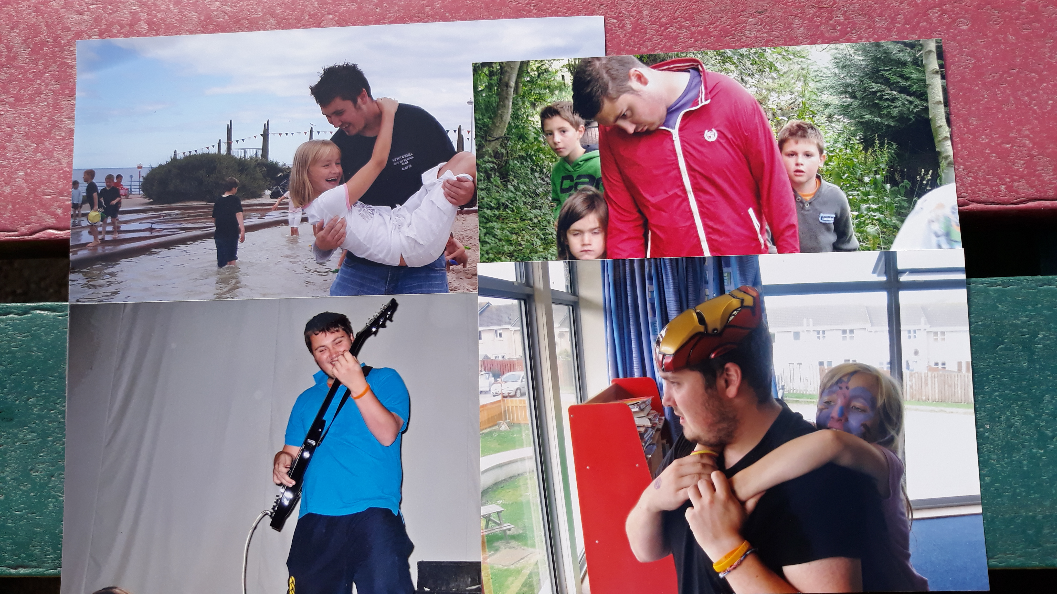

**Staff: -Commitee**

**Club Manager**: Heather Edmond

**Assistant Manager** Vicky McBain

**Senior Practitioner**: Moira Laird

**Practitioners**: Amanda Karpinski, Megan Shepherd, Andrea Berthold

**Support Workers:** Carly Wilson, Kaitlyn Gordon.

**Student Helpers:**

Kieran McHardy, Bailey Donnell, Nicholas Kennedy

We said a farewell to Clara Campbell and Arran Cosgrove who have both left to go to University (hopefully they will be back to work next Summer) we wish them all the best and a massive thank you for all their hard work. Both attended the club as children as it is such a privilege to see them grow up and move on as fantastic young adults.

Staff and children also said a sad farewell to Gavin who lost his 3-year battle with cancer. Gavin had been with the NOOSC team for 13years he came as a young 20-year-old from a nursery setting but he found his true calling with us at Newtonhill Out of School Club. 100’s of children from Newtonhill will have been influenced by Gavin and will be better adults for knowing him.

Bye Gav it has been a pleasure.

**Chairperson:** Leanne Duffy

**Committee members:**

Abbigail Van Zyl Jodie Mathieson June Scott

Natalie Milne Eunice Morgan Clare Leiper

Rhian Morgan Sarah Chew Julie Milne

Ann Stuart Debbie Finlay Karen Nicol

Leiane MacLeod

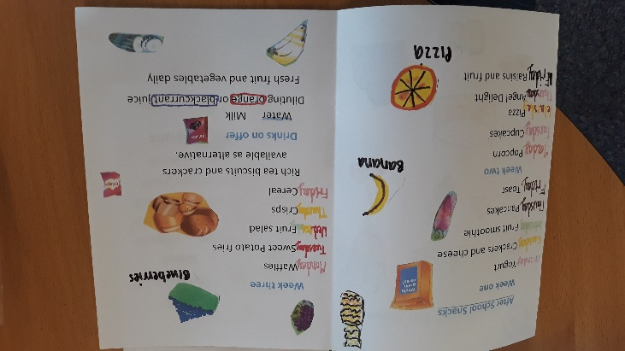

**A.G.M. ENROLEMENT NIGHT**

Normally we would be inviting you to our A.G.M in October to enrol your child/ren for another year and to see what we have been up to during the year. Due to government restrictions we will have to re-think and hold our A.G.M another way. Enrolment forms will be posted to you please complete and return as soon as possible. We understand things are difficult some people are still on furlough etc but we need the completed forms to allow us to plan for the future of the club.

Care plans will be included with enrolment forms please sign and return. We were marked down by the Care Inspectorate for not getting these signed and we are now looking at ways to make this easier.

**Children Information**

The children have been enjoying ordering new toys and equipment. We have received donations from P7 prom Committee and from families who have left the club as the children have gone to the Academy massive thank you for thinking of us.

We also completed Sponge Bob for the Chapleton Skarecrow Competition (thank you Mr Edmond) it was not an entre we just like to take part. NOOSC was also lucky to be chosen as one of the Charities to receive funding.

Children are now busy planning our October holiday activities canny wait we missed out so much during the Summer. May even manage a trip day.

The children have designed their own menu for the club with healthy snacks chosen by the children. They are now keeping us right with what is on the menu each day Tesco staff are always pleased to see us. Fruit and veg now arrives weekly by van its great excitement.

Out new logo competition is still ongoing and is going to be difficult to choose the winner.

Bus will be out of action the week commencing 21st September so we will be walking the children to and from School. All children must be in by 8.30 so we have time to walk to School. Please ensure children have jackets as we will be walking no matter the weather.

**Contact us: Telephone 07793 561748 01569 731710**

**e-mail** [**Noosc.office@gmail.com**](mailto:Noosc.office@gmail.com) **or face to face (social distancing of course).**

Please remember this is your club we welcome new ideas and suggestions.

**THIS IS YOUR CLUB WE WELCOME NEW IDEAS AND SUGGESTIONS.**

